**Program Book**

**Community Service Project**

Program Book COMMUNITY SERVICE PROJECT

**AP STATE COUNCIL OF HIGHER EDUCATION**

**(A STATUTORY BODY OF GOVERNMENT OF ANDHRA PRADESH)**



### COMMUNITY SERVICE PROJECT REPORT

On

**SMOKING AND ALOCHOL IS INJURIOUS AND THEIR IMPACT ON FAMILIES AND SOCIETY**

By

### POLLAKATTU KARTHIK 21JN1A05C7

Under the guidance of

### Mr.N.HARISH KUMAR, M.Tech,

**Assistant Professor**

### DEPARTMENT OF CSE

****

### DEPARTMENT OF

**COMPUTER SCIENCE AND ENGINEERING**

|  |
| --- |
| **SREE VENKATESWARA COLLEGE OF ENGINEERING** |
| (Approved by AICTE, New Delhi and Affiliated to Jawaharlal Nehru Technological University – Anantapur) |
| GOLDEN NAGAR, NH5 BYPASS ROAD, NORTH RAJUPALEM, KODAVALURU (V&M), SPSR NELLORE  An ISO 9000:2015 Certified Institution |

**2022-2023**

**Program Book For**

**Community Service Project**

**Name of the Student: POLLKATTU KARTHIK**

**Name of the College:** Sree Venkateswara College Of Engineering

**Registration Number:** 21JN1A05C7

**Period of CSP: 5WEEKS From:** 1 MAY 2023 **To**: 24 JUNE 2023

### Title: SMOKING AND ALCOHOL IS INJURIOUS AND THEIR IMAPCT ON FAMILIES AND SOCIETY

### Name & Address of the Community/Habitation:

### Z.P HIGH SCHOOL

### KODAVALURU,

### S.P.S.R NELLORE,

### A.P

**Community Service Project Report**

### Submitted in accordance with the requirement for the degree of B.Tech

Name of the College : Sree Venkateswara College Of Engineering Department : Computer Science and Engineering

Name of the Faculty Guide : Mr.N.HARISH KUMAR, M.Tech.

Assistant Professor

Department of CSE

Title : SMOKING AND ALCOHOL IS INJURIOUS AND THEIR IMPACT ON FAMILES AND SOCIETY

Duration of the CSP :**From:** 1 MAY 2023 **To**: 24 JUN 2023 Name of the Student : POLLAKATTU KARHTIK

Programme of Study : UG, B.TECH

Year of Study : 3rd year

Register Number : 21JN1A05C7

Date of Submission :

**Student’s Declaration**

I am POLLAKATTU KARTHIK, a student of III year B.Tech Program, Reg. No. **21JN1A05C7** of the Department of CSE, In SREE VENKATESWARA COLLEGE OF ENGINEERING College do hereby declare that I have completed the mandatory community service project from MAY 1 to JUNE 24 in smoking and alcohol is injurious and their impact on familes Program under the Faculty Guideship of **Mr.N.HARISH KUMAR, M.Tech., Assistant Professor, Department of CSE** in SREE VENKATESWARA COLLEGE OF ENGINEERING .

(Signature and Date)

#### Endorsements

Faculty Guide

Head of the Department

Principal

**Certificate from Official of the Community**

This is to certify that **POLLAKATTU KARTHIK** Reg. No **21JN1A05C7** of SREE VENKATESWARA COLLEGE OF ENGINEERING underwent community service project from 1st MAY to 24th JUNE 2023 .

The overall performance of the Community Service Volunteer during his/her community service is found to be (Satisfactory/Good).



Authorized Signatory with Deal and Seal PhotoRoom-20230107_140152

#### ACKNOWLEDGEMENTS

I would like to take this opportunity to acknowledge everyone who has helped us in every stage of this project. I express my deep sense of gratitude to all those who have been instrumental in preparation of this project.

My most sincere and grateful acknowledgments to **Dr. P. GUNA SEKHAR, CHAIRMAN** who took keen interest and encouraged us in every effort throughout this course.

I own my gratitude to **Dr. P. ANIL KUMAR, Principal**, SREE VENKATESWARA COLLEGE OF ENGINEERING, NELLORE and **Mr. M. K.VENKATA NAGENDRA, M.Tech., (Ph.D)**,Associate Professor and Head of the Department, Computer Science and Engineering for giving us the opportunity to do this community service project on the topic school

I take this opportunity to express my sincere deep sense of gratitude to our guide, **Mr.N.HARSIH KUMAR M.Tech., Assistant Professor, Department of CSE**, for her significant suggestions and help in every respect to accomplish the report.

I would like to thank Community Service Project coordinator **Mr. G.VIDYA SAGAR, M.Tech., Assistant Professor ,Department of CSE** for his persisting encouragement and keen interest in discussions have benefited us to an extent that cannot be spanned by words.

Also I would like to thank HEAD MISTRESS OF Z.P HIGH SCHOOL (VARIKUNTAPADU), for her constant support and encouragement.

Finally I am thankful to the technical and non-technical staff of SREE VENKATESWARA COLLEGE OF ENGINEERING, NELLORE, and also parents, friends and all my well-wishers for their assistance in finishing the Community Service Project Successfully.

**POLLAKATTU KARTHIK**

**21JN1AO5C7**

## CHAPTER 1: EXECUTIVE SUMMARY

**Introduction:** Smoking and alcohol consumption are two prevalent behaviors that have significant and well-documented health risks. They have long been recognized as leading causes of preventable illnesses and contribute to numerous health issues and diseases. This introduction serves as a brief overview of the detrimental effects of smoking and alcohol consumption on an individual's health, highlighting the importance of making informed choices for a healthier and more fulfilling life. Smoking is the inhalation of tobacco smoke, primarily through cigarettes, cigars, and pipes. It is a leading cause of preventable deaths worldwide and is associated with a wide range of health problems. Cigarette smoke contains more than 7,000 chemicals, including at least 250 that are known to be harmful, and over 60 that can cause cancer. The most notorious of these is nicotine, an addictive substance that makes quitting smoking a formidable challenge. Alcohol, while socially acceptable in moderation, can become a harmful substance when abused. Excessive alcohol consumption can lead to both immediate and long-term health consequences. Alcohol can impair judgment, motor skills, and coordination, which can result in accidents and injuries. Prolonged heavy drinking can damage the liver, heart, and other vital organs, while also contributing to mental health issues and addiction. The detrimental effects of smoking and alcohol are not limited to individual health alone. They also have a significant impact on families, communities, and healthcare systems. It is essential to be aware of the risks associated with these behaviors and to encourage healthier alternatives and support for those looking to quit smoking or reduce alcohol consumption. In the following sections, we will delve into the specific health risks and consequences of smoking and alcohol consumption. Understanding these risks can serve as a strong motivator for individuals to make informed choices about their health and well-being..

**Important factors that contribute to agriculture are:**

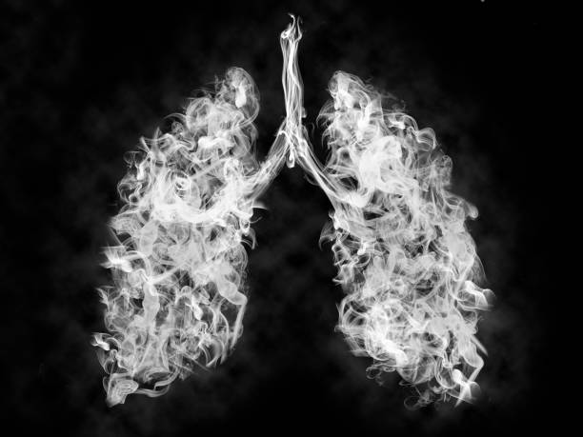 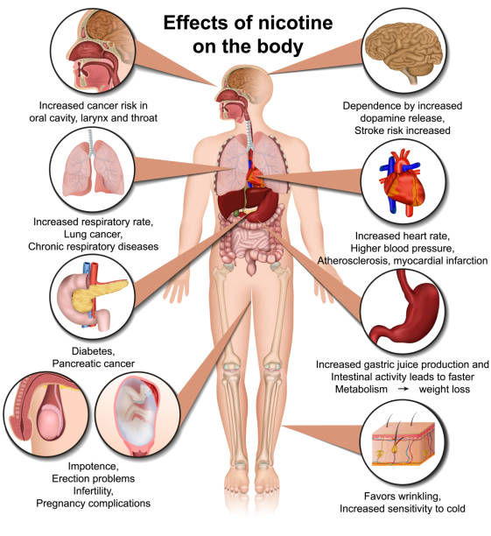

Alcohol, while socially acceptable in moderation, can become a harmful substance when abused. Excessive alcohol consumption can lead to both immediate and long-term health consequences. Alcohol can impair judgment, motor skills, and coordination, which can result in accidents and injuries. Prolonged heavy drinking can damage the liver, heart, and other vital organs, while also contributing to mental health issues and addiction. The detrimental effects of smoking and alcohol are not limited to individual health alone. They also have a significant impact on families, communities, and healthcare systems. It is essential to be aware of the risks associated with these behaviours and to encourage healthier alternatives and support for those looking to quit smoking or reduce alcohol consumption.

**CHAPTER 2: OVERVIEW OF THE COMMUNITY**

Smoking has numerous detrimental effects on the lungs, which are critical for the exchange of oxygen and carbon dioxide in the body. Here's a brief description of some of the major effects of smoking on the lungs:

**Chronic Obstructive Pulmonary Disease (COPD):** Smoking is the primary cause of COPD, a group of lung diseases that include chronic bronchitis and emphysema. In chronic bronchitis, the air passages in the lungs become inflamed and narrowed, leading to increased production of mucus and persistent coughing. Emphysema involves the destruction of air sacs in the lungs, making it difficult to breathe.

**Lung Cancer:** Smoking is the most significant risk factor for lung cancer. The harmful chemicals in tobacco smoke damage lung cells, leading to the uncontrolled growth of abnormal cells. Lung cancer can be aggressive and is often diagnosed at an advanced stage, making it challenging to treat.

**Reduced Lung Function:** Smoking leads to reduced lung function over time. It diminishes lung capacity and the ability to breathe deeply. Smokers often experience shortness of breath during physical activities.

**Increased Risk of Respiratory Infections:** Smokers are more susceptible to respiratory infections like pneumonia and bronchitis. Smoking weakens the immune system's ability to fight off infections, and the damaged airways are more vulnerable to bacterial and viral invaders.

**Worsening of Asthma:** Smoking exacerbates the symptoms of asthma. It can lead to more frequent and severe asthma attacks, making it harder for individuals with asthma to manage their condition.

**Irritation and Inflammation:** Smoking irritates the airways and causes inflammation, leading to a persistent cough and increased production of phlegm. It also triggers spasms in the airway muscles.

**Impaired Ciliary Function:** The respiratory system has tiny hair-like structures called cilia that help clear mucus and foreign particles from the lungs. Smoking impairs the ciliary function, making it harder for the lungs to remove debris and contaminants.

It's important to note that the damage caused by smoking to the lungs is cumulative and often irreversible. Quitting smoking can significantly reduce the risk of further harm and improve lung health. Additionally, early detection and treatment of smoking-related lung conditions are crucial for better outcomes.

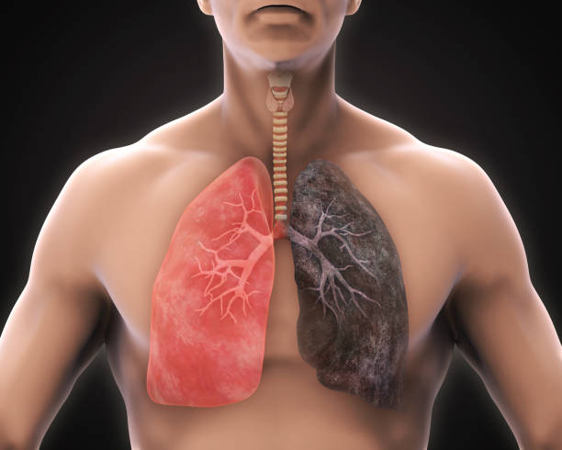

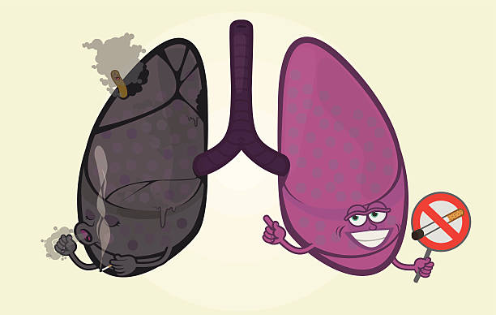

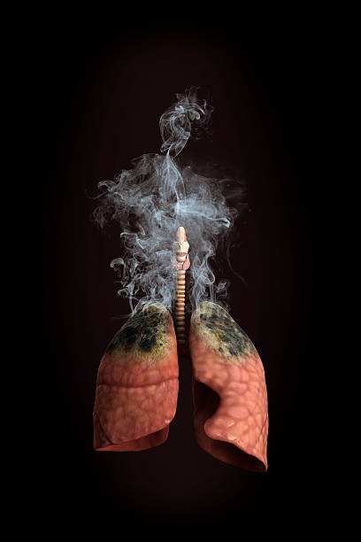

## CHAPTER 3: COMMUNITY SERVICE PART

Alcohol consumption, when done in moderation, may have some limited health benefits, such as the potential protective effects of moderate red wine consumption on heart health. However, excessive and irresponsible alcohol consumption poses significant risks and is detrimental to overall health. Here's a description of how alcohol can be injurious to health:

**Liver Damage:** The liver is responsible for processing and metabolizing alcohol. Excessive drinking can lead to various liver conditions, including fatty liver, alcoholic hepatitis, fibrosis, and cirrhosis. Chronic alcohol abuse can severely damage the liver and may even lead to liver failure.

**Cardiovascular Issues:** While moderate alcohol intake can have some cardiovascular benefits, excessive drinking can lead to high blood pressure, irregular heart rhythms, and cardiomyopathy (weakening of the heart muscle), which can result in heart failure.

**Cancer Risk:** Alcohol consumption is a known risk factor for several types of cancer, including mouth, throat, esophagus, liver, breast, and colorectal cancer. The ethanol in alcohol can damage DNA and promote cancer cell growth.

**Brain and Nervous System:** Prolonged alcohol abuse can lead to neurological problems, including memory and cognitive impairments, peripheral neuropathy, and alcohol-induced brain damage. It can also lead to mental health issues such as depression and anxiety.

**Gastrointestinal Problems:** Alcohol can irritate and damage the digestive system, leading to gastritis, ulcers, and an increased risk of gastrointestinal bleeding. It can also interfere with nutrient absorption.

**Weakened Immune System:** Excessive alcohol consumption weakens the immune system, making the body more susceptible to infections and diseases. It can also impair the body's ability to recover from illnesses and injuries.

**Dependency and Addiction:** Alcohol is an addictive substance, and heavy drinking can lead to alcohol dependency and addiction. Withdrawal symptoms, such as tremors and seizures, can occur when an individual tries to quit drinking.

**Social and Psychological Consequences:** Alcohol abuse can lead to a host of social and psychological problems, including strained relationships, legal issues, job loss, and financial troubles. It can also contribute to reckless behaviors, accidents, and even violence.

**Impaired Judgment and Accidents:** Alcohol impairs judgment, coordination, and reaction times. This leads to an increased risk of accidents, including car crashes, falls, and injuries

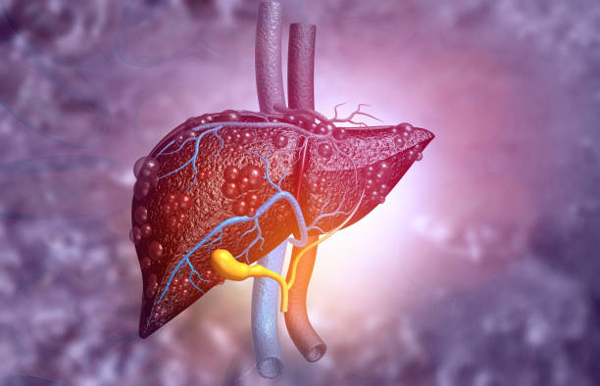

## ACTIVITY LOG FOR THE FIRST WEEK

|  |  |  |  |
| --- | --- | --- | --- |
| **DAY**  **&**  **DATE** | **BRIEF DESCRIPTION OF THE DAILY**  **ACTIVITY** | **LEARNING OUTCOME** | **Person In-charge Signature** |
| **Day –1** | Conducted survey on people who have addicted to smoking | I have visited some places in my village and conducted survey and gathered information |  |
| **Day- 2** | Conducted survey on people who have addicted to alcohol consumption | I have visited some places in my village and conducted survey and gathered information |  |
| **Day- 3** | Today I went to tushion where there are bunch of students and explained them about the smoking is injurious to health And the side effects of the smoking | They understand that the smoking is injurious health and how it affects the health |  |
| **Day- 4** | I have formed a group of people and explain them about the effects of smoking and alcohol and how it effects their and families and the society | I briefly explained the side effects of the smoking and alcohol consumption and the various health problems of them |  |

#### WEEK-1 REPORT

**On day 1:** I performed survey on people who are addicted to smoking and gathered the information

**On day 2**: I performed survey on people who are addicted to alcohol consumption and gathered the information.

**On day3**: I gathered the group of people and briefly explained them about the how smoking affects the body and health diseases which are occurred by the smoking.

* **Smoking raises the cancer risk almost everywhere in the body**
* **Increases risk of the heart attack**
* **By smoking increases the gum disease risk**

**On day 4**: : I gathered the group of people and briefly explained them about the how alcohol affects the body and health diseases which are occurred by the alcohol consumption.

* **Increases cancer risk in oral cavity ,larynx and throat**
* **Fatty liver and liver cirrhosis, shrink liver , liver cancer**

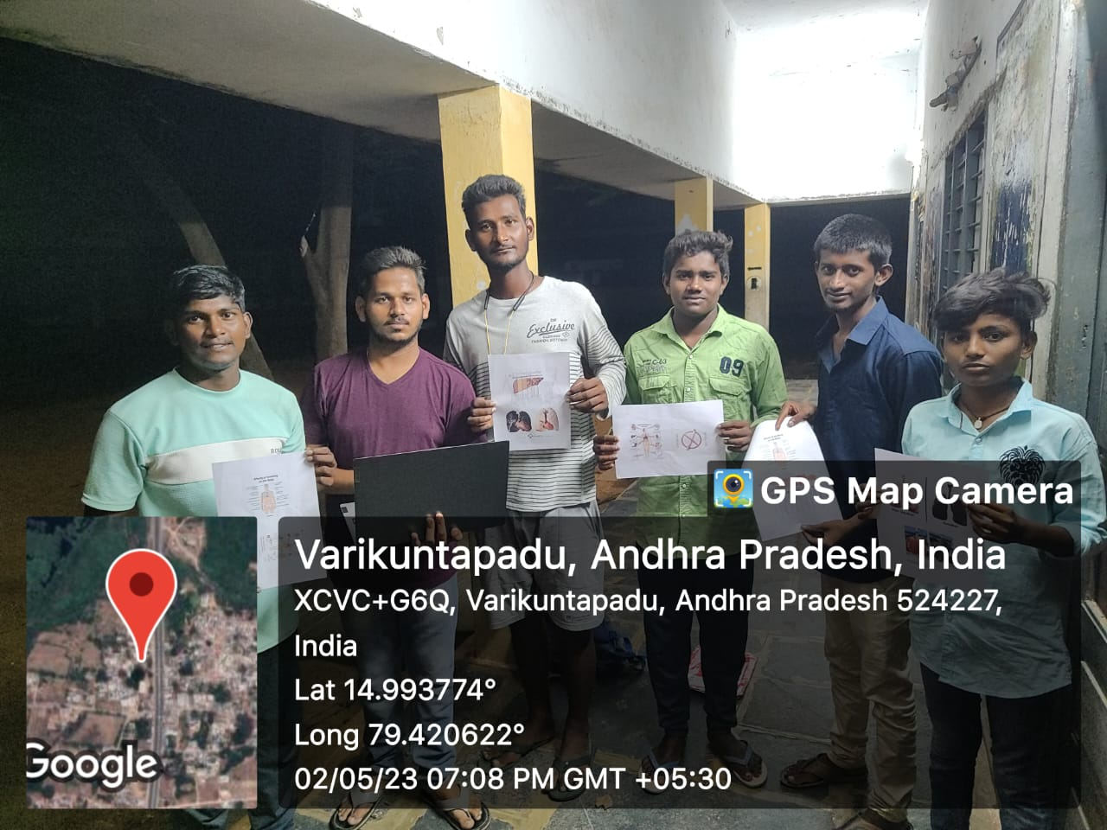

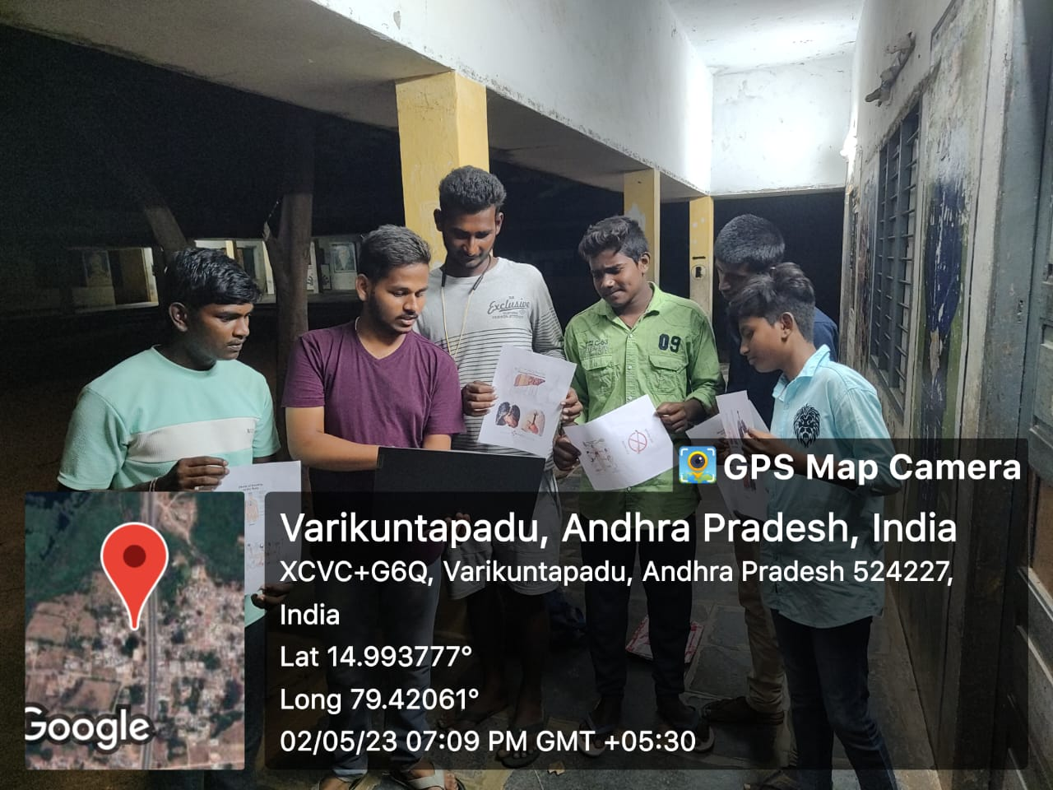

## ACTIVITY LOG FOR THE SECOND WEEK

|  |  |  |  |
| --- | --- | --- | --- |
| **DAY**  **& DATE** | **BRIEF DESCRIPTION OF THE DAILY ACTIVITY** | **LEARNING OUTCOME** | **Person In-charge Signature** |
| **Day –1** | I gathered students in locality and I spread the knowledge about adverse effects of smoking and alcohol effects. | They understood the effects of smoking alcohol. |  |
| **Day – 2** | I gathered a group of working people in another locality and I thought them that how those products are harmful and how they were produced with many harmful elements. | They understood that the products very harmful to their health and they produces various health diseases |  |
| **Day – 3** | On last day I conducted an awareness program in a locality and told them to avoid the smoking &drinking habits and explained them the causes of the smoking and drinking. | The people in that locality understood very well about my program and raised some |  |

#### WEEK-2 REPORT

**On Day1:** As part of my csp project I went to sachivalayam and took permission to conduct my awareness program and they granted permission.

**On day 2: T**oday I went to locality and gathered a group of students andI spread the knowledge about the adverse effects of smoking and alcohol consumption and they understood the effects of smoking and it is injurious to their health

**On day 3**:today I went locality and gathered some working people and I thought them that how those products are harmful and how they were produced with many harmful elements. they understood the effects of smoking and alcohol consumption.

**On day 4:** on last day I conducted awareness programs in locality on smoking and alcohol consumption is injurious to health and how it affects their families and society. The people in that locality understood very well and they realised that smoking causes severe damage to their health and because of this their families will suffer.after they listening to my words they are willing to avoid the smoking and drinking and encourages others to avoid those bad habits.

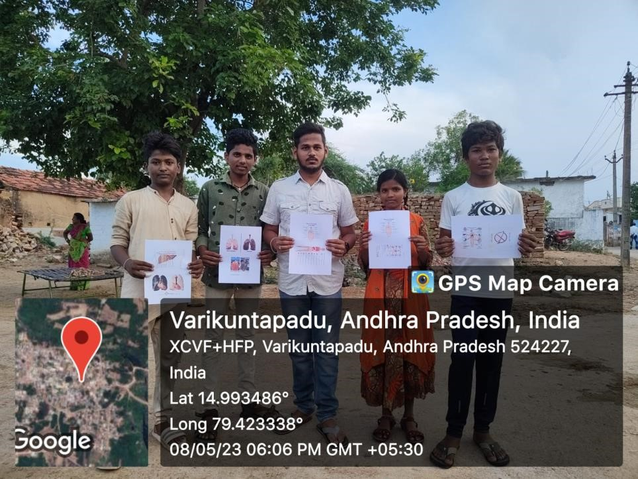

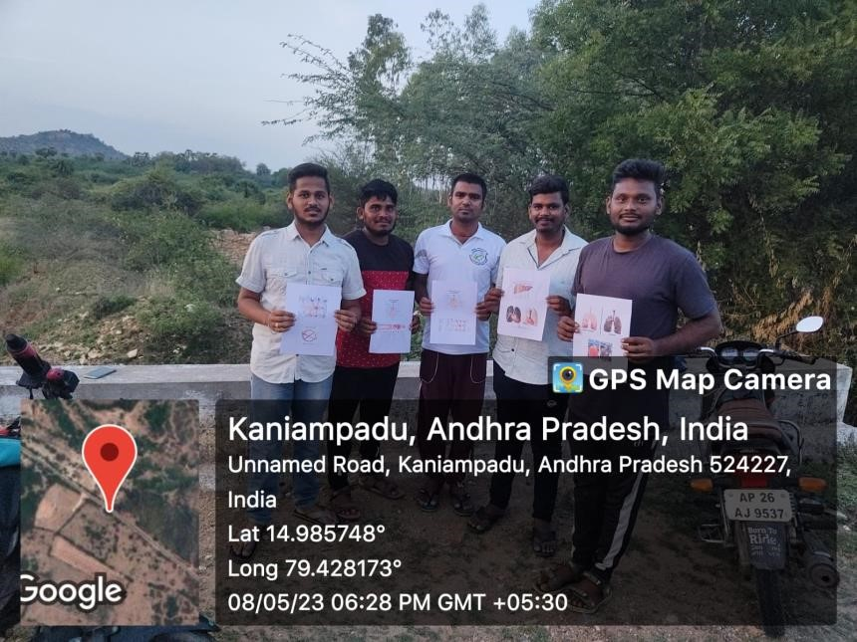

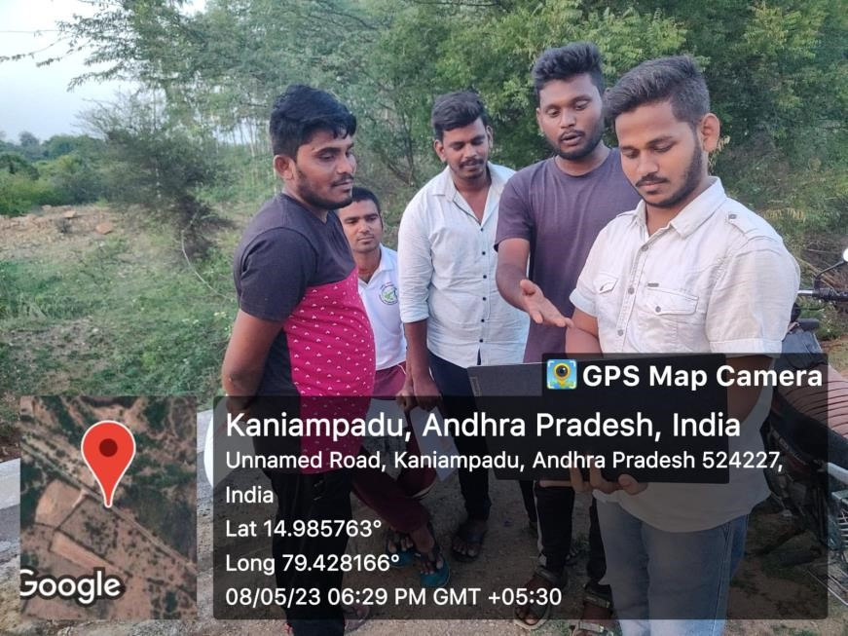

## ACTIVITY LOG FOR THE THIRD WEEK

|  |  |  |  |
| --- | --- | --- | --- |
| **DAY**  **& DATE** | **BRIEF DESCRIPTION OF THE DAILY ACTIVITY** | **LEARNING OUTCOME** | **Person In-charge Signature** |
| **Day –1** | I started my awareness program and gathered a group ladies and explained them about the affects caused by smoking and alcohol and how todays kids are addicting to them and said to prevent their family members from addicting to smoking and alcohol consumption. | Through my awareness program they got to know that how smoking causes damage to their health and also what are the diseases that will affect when you are addicted to smoking and alcohol consumption. |  |
| **Day –2** | Today I went to work place where there many people working so that I can share my project theme to more members by my awareness program and thought them by showing some videos of affected people by these smoking and drinking habits. And also showed some pictures of how lungs and liver damaged. | The people understood that how lungs and liver got damaged and also understood that very dangerous chemicals are added in the smoking &drinking products. |  |
| **Day-3** | Today also I went to a place and gathered some members and explained my project theme and explained them the major effects caused by these bad habits. | The people understood the major effects of the smoking and drinking . |  |

#### WEEKLY-3 REPORT

* started my awareness program and gathered a group ladies and explained them about the affects caused by smoking and alcohol and how todays kids are addicting to them and said to prevent their family members from addicting to smoking and alcohol consumption. Through my awareness program they got to know that how smoking causes damage to their health and also what are the diseases that will affect when you are addicted to smoking and alcohol consumption.
* Today I went to work place where there many people working so that I can share my project theme to more members by my awareness program and thought them by showing some videos of affected people by these smoking and drinking habits. And also showed some pictures of how lungs and liver damaged. The people understood that how lungs and liver got damaged and also understood that very dangerous chemicals are added in the smoking &drinking products

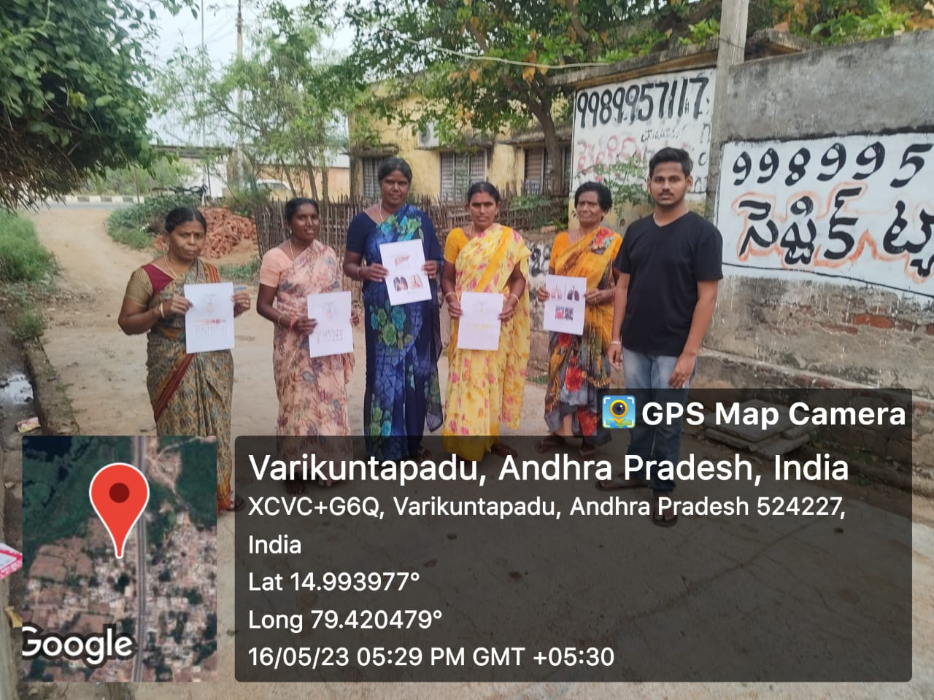

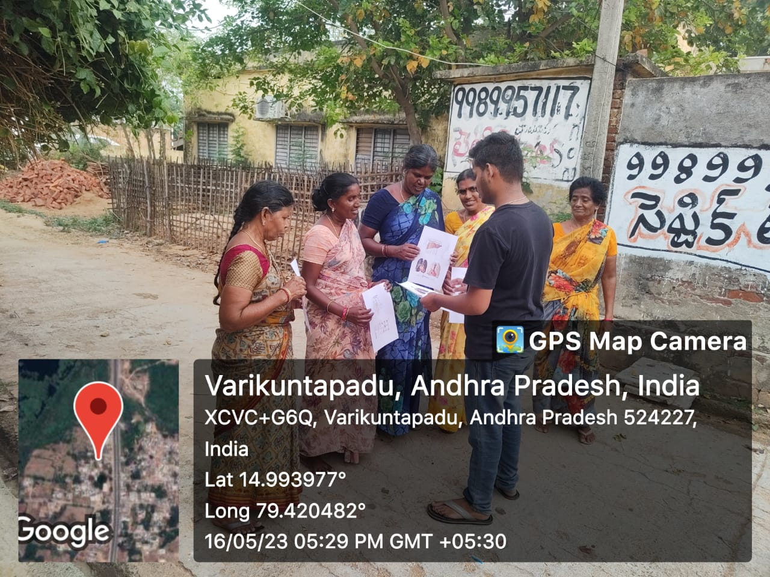

## ACTIVITY LOG FOR THE FOURTH WEEK

|  |  |  |  |
| --- | --- | --- | --- |
| **DAY**  **& DATE** | **BRIEF DESCRIPTION OF THE DAILY ACTIVITY** | **LEARNING OUTCOME** | **Person In-charge Signature** |
| **Day –1** | I went to a working place and gather people and explained them how today kids are addicting to these bad habits and how it affects their life and explained the major effects being occurred by these bad habits. | The people understood that how the kids are addicting to these habits and how their lives being affected by this alcohol and smoking consumption in their early stage. |  |
| **Day-2** | Today also I went to a working place and gathered a group of people and explained them the major health effects being raised by this smoking and alcohol consumption and I shown some photos of affected lungs and explained the health effects. | They realised by seeing the photos of how the lungs affected by the smoking and the diseases caused by the smoking. |  |
| **Day-3** | On day 3 I gather some people and shown them how the lever being affected by taking alcohol and what are the diseases will raise after the taking alcohol and what are the preventions to avoid these smoking and drinking habits | The people were realised that these smoking and alcohol consumption effects their families severely and causes cancers and also lot of diseases. |  |

#### WEEK-4 REPORT

Effects of drinking alcohol:

**Fatty Liver (Alcoholic Steatosis):** Even short-term excessive drinking can lead to a condition known as fatty liver, where fat accumulates in liver cells. This condition is reversible if alcohol consumption is stopped. However, it can progress to more severe liver damage if drinking continues.

**Alcoholic Hepatitis:** This is an inflammation of the liver caused by excessive alcohol intake. Symptoms may include jaundice (yellowing of the skin and eyes), abdominal pain, nausea, vomiting, and fever. Alcoholic hepatitis can range from mild to severe, and severe cases can be life-threatening.

**Fibrosis:** Long-term alcohol abuse can lead to the formation of fibrous tissue in the liver. This is known as liver fibrosis. It's a precursor to more severe liver conditions like cirrhosis.

**Cirrhosis:** Cirrhosis is the advanced scarring of the liver tissue. It's a result of long-term, continuous damage to the liver and may be the final stage of alcoholic liver disease. Cirrhosis can lead to liver failure. It can cause a range of symptoms and complications, including fluid retention, confusion, easy bruising and bleeding, and increased pressure in the blood vessels of the liver (portal hypertension).

**Increased Risk of Liver Cancer:** Alcohol abuse is a major risk factor for developing liver cancer. Chronic liver inflammation and cirrhosis increase the risk of liver cancer, which can be especially deadly.

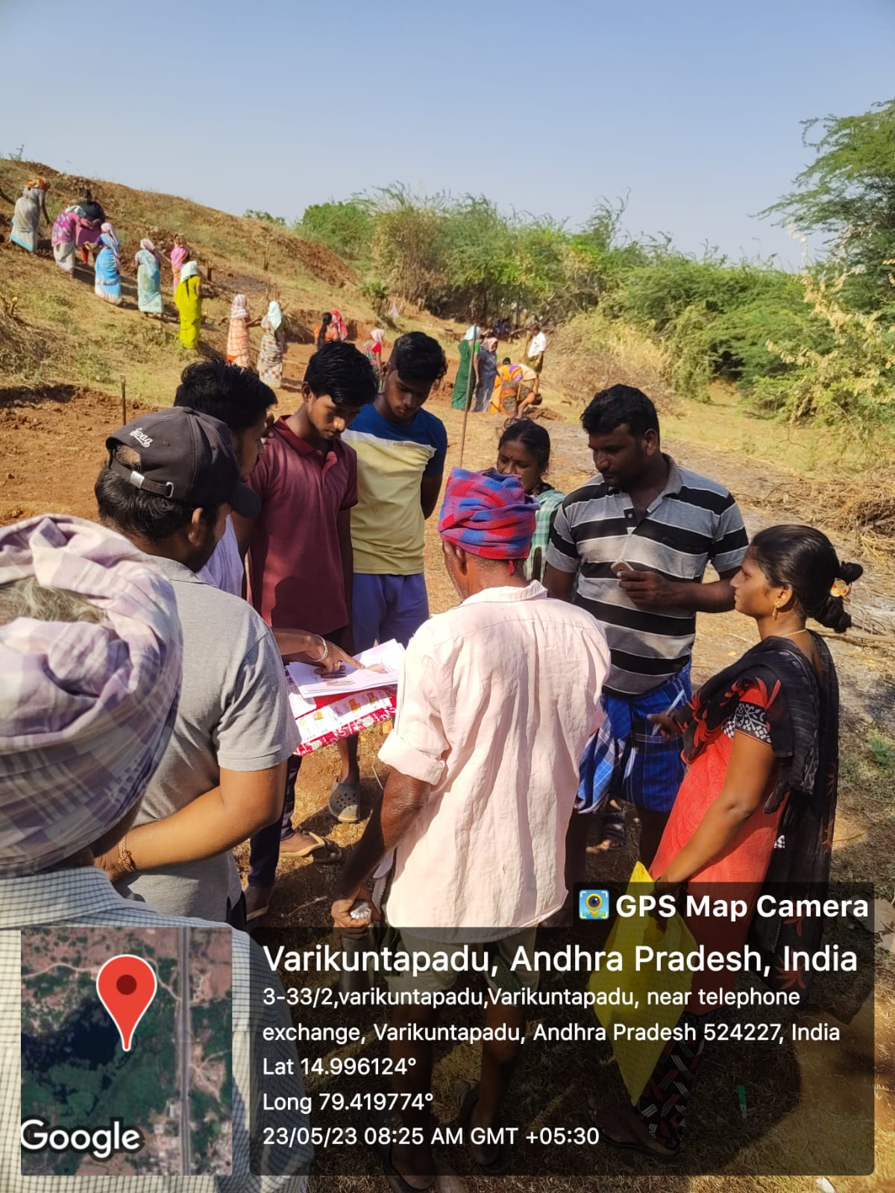

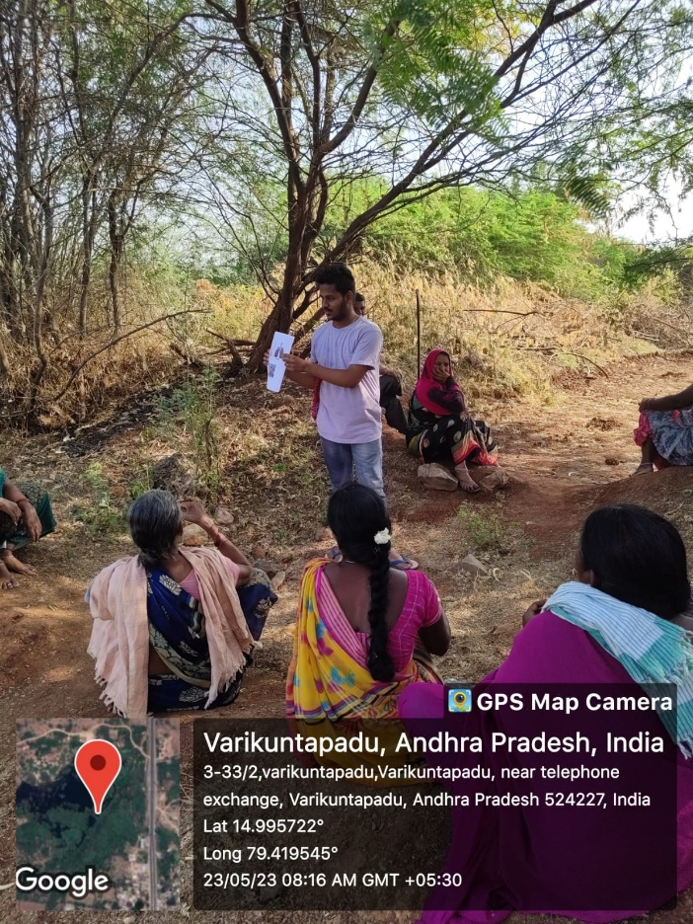

## ACTIVITY LOG FOR THE FIFTH WEEK

|  |  |  |  |
| --- | --- | --- | --- |
| **DAY**  **& DATE** | **BRIEF DESCRIPTION OF THE DAILY ACTIVITY** | **LEARNING OUTCOME** | **Person In-charge Signature** |
| **Day – 1** | I conducted survey in my village on teenagers who are addicted to smoking and as well as drinking and I got to know that 2 people were badly addicted to the smoking and drinking and it affects their family and also on his career so I will go to them and explain the how his career is damaging because of this bad habit and also his family and try to explain the things affected by is bad habits. | I collected some photos and videos to explain them how the health is damaging because of these addictions and also I will explain them avatar career is losing because of these addictions. |  |
| **Day-2** | Today I went to a person who is addicted to smoking and alcohol consumption very badly and I explained him by showing the photos and videos of damaged lungs and livers and also explain him what are the major effects being affected by these alcohol and smoking consumption and I showed him how much tobacco percentage in the cigarettes and how danger it is and I show him how much alcohol | After listening my words and seeing those pictures he realised how badly he is injured taking these smoking and alcohol and he understood what are the effects being affected when he took those smoking and how his family suffering |  |
| **Day-3** | On last day I met the families of those 2 people and explained them how these smoking causes severe damage to health and it affects on their studies and society. after knowing that their son quit the smoking they felt very happy. | The parents of those two people felt very happily after knowing that they kidsquit the smoking. |  |

#### WEEK-5 REPORT

Smokers also face an elevated risk of cardiovascular diseases. The harmful chemicals in tobacco smoke lead to the narrowing of arteries, high blood pressure, and the formation of artery-clogging plaques, increasing the likelihood of heart attacks and strokes. Moreover, smoking contributes to the hardening of blood vessels, reducing blood flow to the heart and the rest of the body.

The adverse effects of smoking are not limited to the respiratory and circulatory systems. Smokers are at higher risk for various cancers, including those of the mouth, throat, esophagus, pancreas, and bladder, among others. Smoking can damage almost every organ in the body and is known to weaken the immune system, making it harder to fight off infections. Additionally, it has detrimental effects on oral health, causing tooth decay, gum disease, and bad breath.

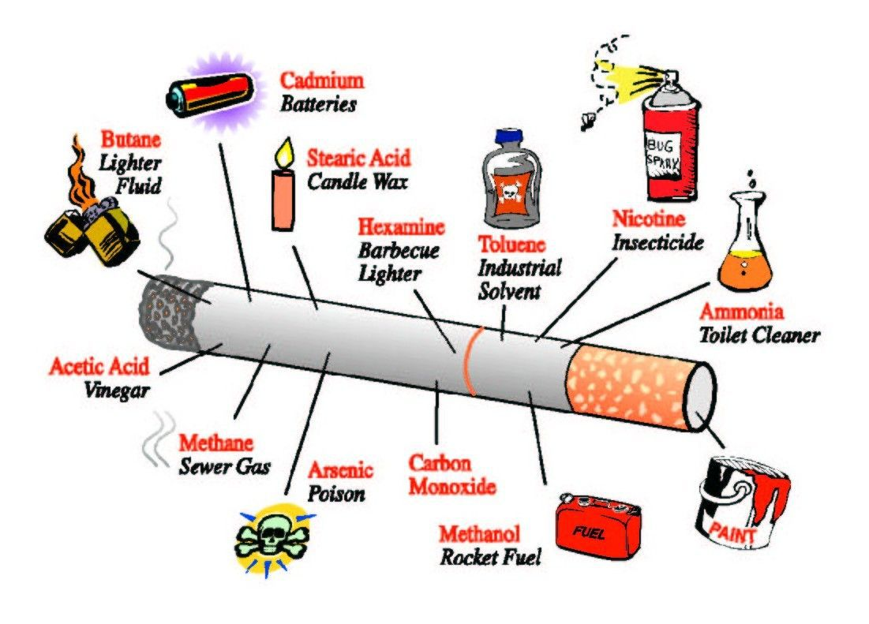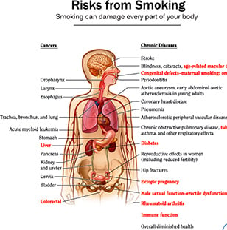

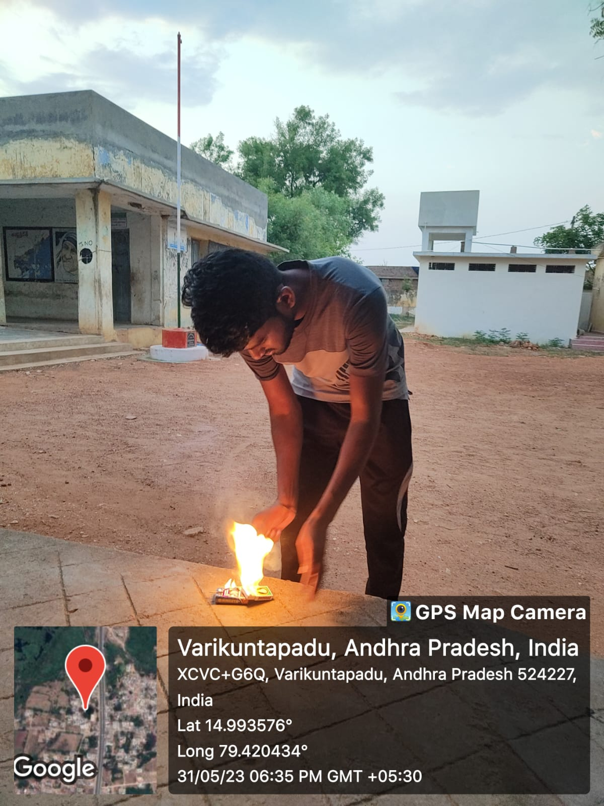 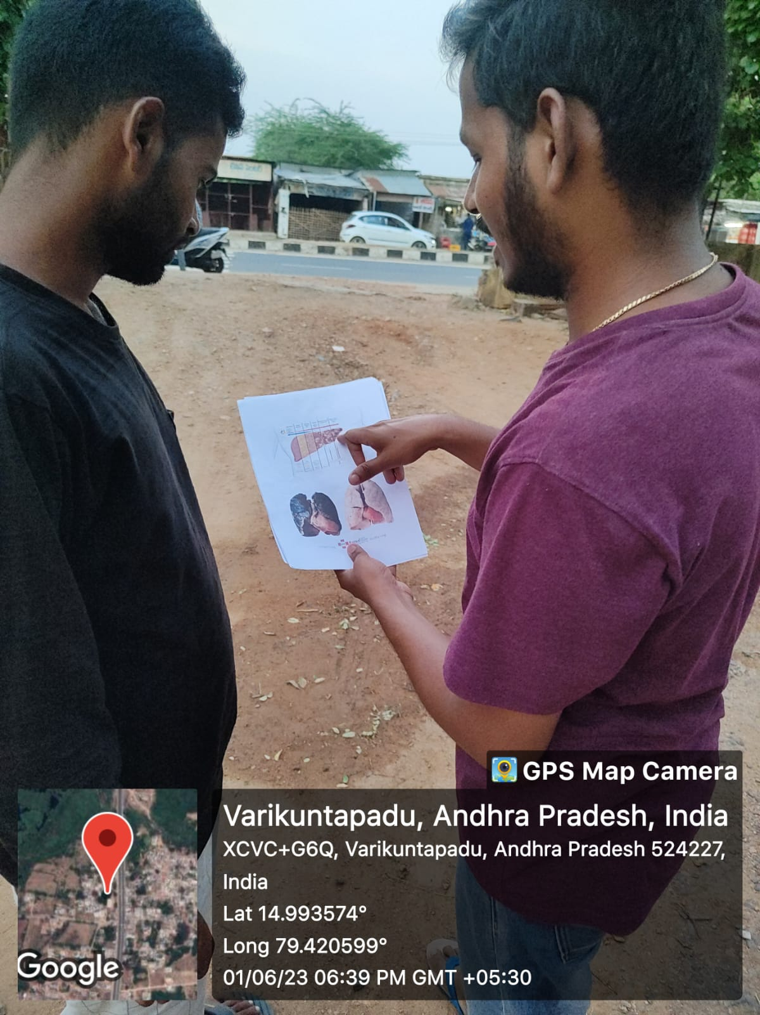

**CHAPTER 5: OUTCOMES DESCRIPTION**

* We are explaining about what is the agriculture?.
* We explain about seeds to develop agriculture.
* We gave the basic ideas about the farming.
* Students will demonstrate the ability to analyze data and draw appropriate statistical conclusions.
* Students will demonstrate the ability to communicate effectively both orally and in writing.
* Students will demonstrate knowledge of the legal and ethical environment impacting agriculture organizations and exhibit an understanding and appreciation of the ethical implications of decisions.
* Students will demonstrate an understanding of and appreciation for the importance of the impact of globalization and diversity in modern agriculture organizations.
* Students will demonstrate an ability to engage in critical thinking by analyzing situations and constructing and selecting viable solutions to solve problems.
* Students will demonstrate an ability to work effectively with others.
* Students will understand and analyze the current events and issues that are occurring in agriculture and how they affect your future in agriculture.
* Students will be able to recognize and examine the relationships between inputs and outputs in their agricultural field to make effective and profitable decisions.
* Students will understand how all aspects of agriculture combine and are used by scientists, marketers, and producers.
* Students will understand how employer characteristics and decision-making at various levels enhance the success of an agricultural enterprise.
* Students will be able to demonstrate critical thinking and problem solving skills as they apply to a variety of animal and or plant production systems.

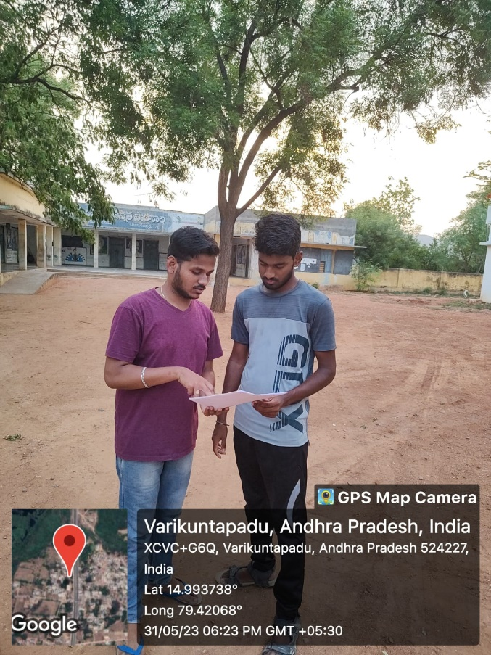 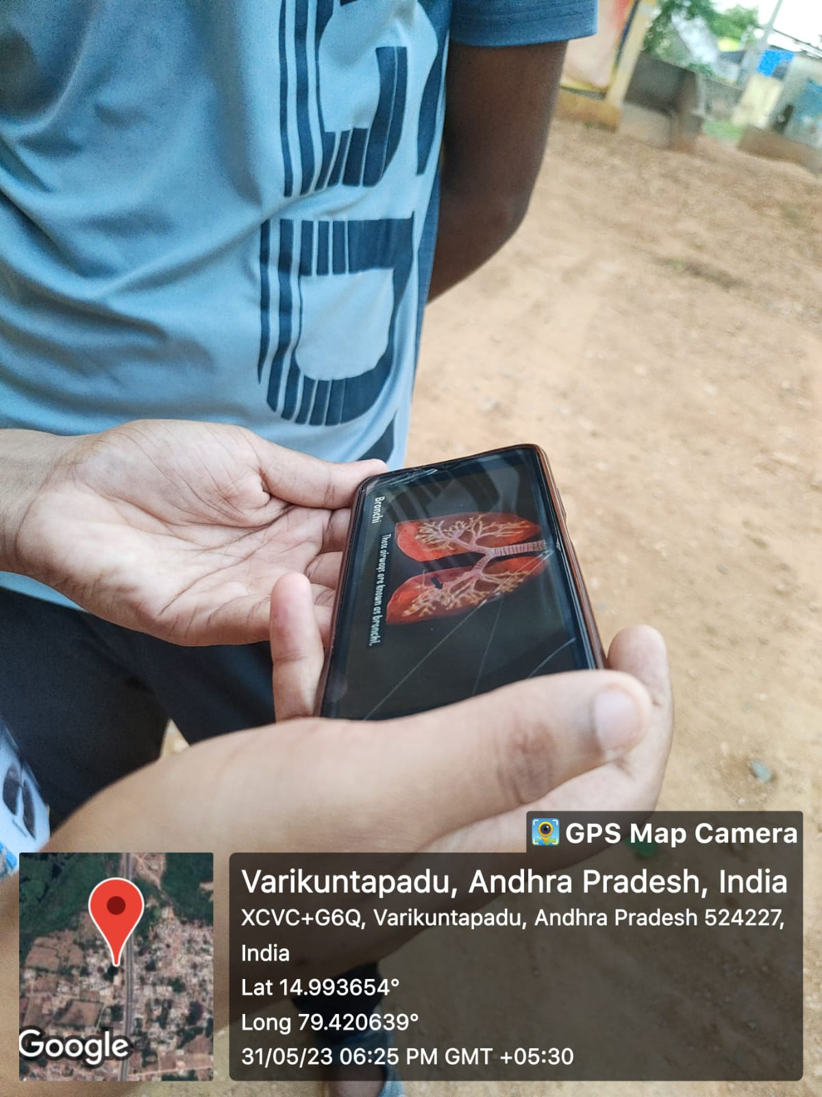

## Report of the mini-project work done in the related subject w.r.t the

## habitation/village.

**SMOKING AND ALCOHOL IS INJURIOUS AND THEIR IMPACTS ON FAMILIES AND SOCIETY**

**ABSTRACT**

**TITLE OF THE PROJECT:** A WEB PAGE DESIGNED ON **“SMOKING AND ALCOHOL CONSUMPTION IS INJURIOUS TO HEALTH”.**

ABSTRACT:

* My project main theme is conduct awareness to the people on smoking and alcohol consumption Is injurious to the health.
* I conducted awareness programs for explaining the people how those bad habits are injurious to the health and effects caused by those smoking and alcohol consumption.
* I taught to the people to avoid these bad habits which affect their carrer and also the family and explained them by showing some photos and videos of damaged lungs etc..
* I explained to the parents to prevent their kids from those cigars and alcohols which can affect their health in their early stage .so it also affects their family and career.
* I explained the major diseases will affect after consmption of smoking and tried to change the people to quit the bad habits.
* I went to two teenagers who are badly addicted to smoking and explained them that how their career effected by those bad habits and shown some pictures. finally they realised these habits are very dangerous and started to quit them.

**EXISTING SYSTEM:**

* Before I visited the village the people are unaware about the effects of the smoking and alcohol consumption.
* The people addicted to those habits are unaware about that those habits will cause severe damage to their health.
* I found that most of the people were addicted to smoking and drinking and ruining their life.
* The parents also unaware how to prevent their kids from addicting to the bad habits.
* I found that teenagers are badly addicted to smoking and they don’t know that it will effect their life.

**Proposed system:**

* Through awareness programs, acknowledged the people about the harmful effects of the consumption of smoking and alcohol.
* Explained the people about the prevention of alcohol and smoking habits.
* Interacted with the village people and thought them about the dangerous elements used in smoking and alcohol products.
* Found the teenagers who are badly addicted to the smoking and tried de-addict them from those habits.

**Requirements:**

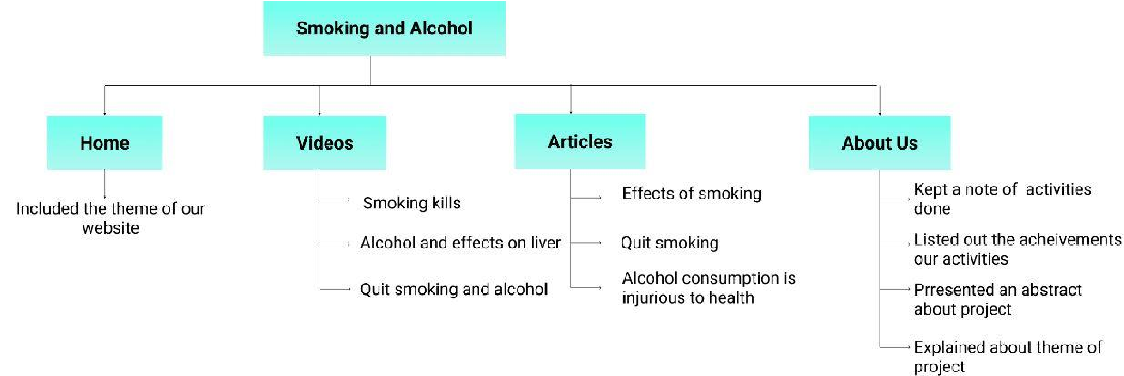o **Hardware:**Laptop,windows11,ryzen processer,512GB SSD,16GB RAM. o **Software**: vs code, html5,3.

**Architecture:**

**User&admin:**

We have designed a website which could be accessed by any user without any restrictions . i.e , both user and admin have same access for the website.

**MODULES:**

The home page gives the user introduction about the theme of the website and the reason to which it was built. The home page consists of an navigation bar which has title of the project (smoking and alcohol is injurious to the health) nav bar consists of the links to Home,News pages along with Login. If an user logs in he can get access to remaining pages from navbar such as Activity , Get Involved , About us , Resources pages. Home page contains the brief intro about smoking and alcohol is injurious to health and the main part is it contains cards describing various diseases prevalent in present society and the preventive measures taken against them.

**VIDEOS:**

In videos I explained about the how smoking kills you and how it effects your health and also what are the health problems will arise by addicting to the smoking . the video gives you a clarity of how smoking causes damage to the health and how it effects the body. I provided videos of alcohol effects on liver and how quit smoking and alcohol.

**ARTICLES:**

The articles explain about the how smoking and alcohol is effects on the body what are effects will arise by addicting too the smoking and alcohol. And also the article provides you detail information about the diseases will come and how to prevent addiction of smoking and alcohol.

**ABOUT US:**

The about us page contains the brief description about what we have done in the following five weeks with the photos and the description about activities conducted each week.

**ACTIVITIES:**

The activities page consists of the list of various activities conducted b our csp team in the locality . We kept an get involved button through which the willing volunteers can join our activity and get benifitted and help us to get succeed . the in formation activity such as date of commencement , venue , oranizer’s contact number , no of persons already registered in the activity . there is an comments section provided in the every activity through which the participants can share thei thoughts about the activity and ask douts to fellow participants .

**CONCLUSION:**

This website is created to create awareness and educate people on various aspects related to smoking and alcohol consumption is injurious to heath.This website helps the people to easily know about the various activities conducted by our team and provides them easy access to all of our activities . this website educates the people in the way of maintaining a good habits practices paves a way to good and healthier future. mobile view and desktop views are supported .By logging in only you can access all pages of website such as activity ,articles , About us , resources pages . so register and login to view full website.

Website Link : https://karthik-csp.netlify.app/

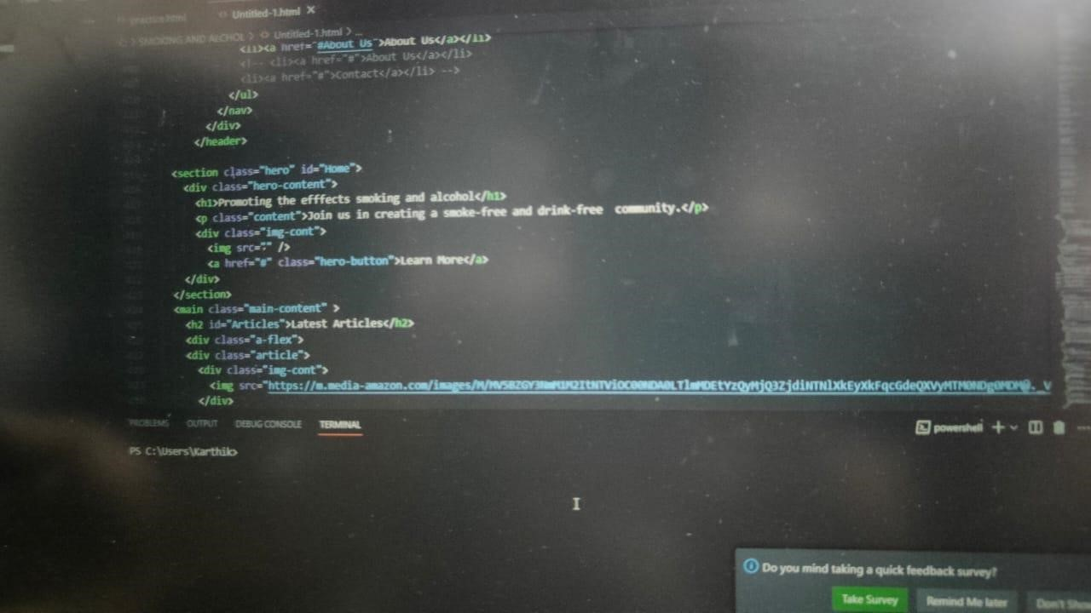

#### Student Self-Evaluation for the Community Service Project

Student Name:POLLAKATTU KARTHIK

Registration No: 21JN1A05C7

Period of CSP: From: MAY 1 2023

To: JUNE 24 2023

Date of Evaluation:

Name of the Person in-charge: Mrs.G.VIDYA SAGAR

Address with mobile number: Nellore district (8074796676)

**Please rate your performance in the following areas:**

**Rating Scale: 1 is lowest and 5 is highest rank**

|  |  |  |  |  |  |
| --- | --- | --- | --- | --- | --- |
| **1) Oral communication** | **1** | **2** | **3** | **4** | **5** |
| **2) Written communication** | **1** | **2** | **3** | **4** | **5** |
| **3) Proactiveness** | **1** | **2** | **3** | **4** | **5** |
| **4) Interaction ability with community** | **1** | **2** | **3** | **4** | **5** |
| **5) Positive Attitude** | **1** | **2** | **3** | **4** | **5** |
| **6) Self-confidence** | **1** | **2** | **3** | **4** | **5** |
| **7) Ability to learn** | **1** | **2** | **3** | **4** | **5** |
| **8) Work Plan and organization** | **1** | **2** | **3** | **4** | **5** |
| **9) Professionalism** | **1** | **2** | **3** | **4** | **5** |
| **10) Creativity** | **1** | **2** | **3** | **4** | **5** |
| **11) Quality of work done** | **1** | **2** | **3** | **4** | **5** |
| **12) Time Management** | **1** | **2** | **3** | **4** | **5** |
| **13) Understanding the Community** | **1** | **2** | **3** | **4** | **5** |
| **14) Achievement of Desired Outcomes** | **1** | **2** | **3** | **4** | **5** |
| **15) OVERALL PERFORMANCE** | **1** | **2** | **3** | **4** | **5** |

**Date: Signature of the Student**

#### Evaluation by the Person in-charge in the Community/Habitation

Student Name: POLLAKATTU KARTHIK

Registration No: 21JN5A05C7

Period of CSP: From: MAY 1 2023 To: JUNE 24 2023

Date of Evaluation:

Name of the Person in-charge: Mr.G.VIDYA SAGAR

Address with mobile number:Nellore district (8074796676)

**Please rate the student’s performance in the following areas:**

**Please note that your evaluation shall be done independent of the Student’s self-evaluation Rating Scale: 1 is lowest and 5 is highest rank**

|  |  |  |  |  |  |
| --- | --- | --- | --- | --- | --- |
| **1) Oral communication** | **1** | **2** | **3** | **4** | **5** |
| **2) Written communication** | **1** | **2** | **3** | **4** | **5** |
| **3) Proactiveness** | **1** | **2** | **3** | **4** | **5** |
| **4) Interaction ability with community** | **1** | **2** | **3** | **4** | **5** |
| **5) Positive Attitude** | **1** | **2** | **3** | **4** | **5** |
| **6) Self-confidence** | **1** | **2** | **3** | **4** | **5** |
| **7) Ability to learn** | **1** | **2** | **3** | **4** | **5** |
| **8) Work Plan and organization** | **1** | **2** | **3** | **4** | **5** |
| **9) Professionalism** | **1** | **2** | **3** | **4** | **5** |
| **10) Creativity** | **1** | **2** | **3** | **4** | **5** |
| **11) Quality of work done** | **1** | **2** | **3** | **4** | **5** |
| **12) Time Management** | **1** | **2** | **3** | **4** | **5** |
| **13) Understanding the Community** | **1** | **2** | **3** | **4** | **5** |
| **14) Achievement of Desired Outcomes** | **1** | **2** | **3** | **4** | **5** |
| **15) OVERALL PERFORMANCE** | **1** | **2** | **3** | **4** | **5** |

**Date: Signature of the Supervisor**

#### PHOTOS AND VIDEO LINKS

